6.7 -- Intermediate Algebra Lecture 6.7: Using Factoring to Solve Word/Application Problems
- Read the word problem carefully,
- Draw a picture (if applicable)
- Find a formula (if you can)
- Make a verbal model (like an equation but with words)
- Fill in verbal model with variables (can be more than one variable, but try to keep it simple but using only one variable)
- Solve problem and turn the answer into a sentence based on original problem.

Example
You are on a building 225 tall obviously, you want to throw something at the people below
You throw a water melon. If height of the water melon is given by the following
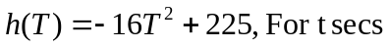
How long will it take for water melon hit the ground.

Height is zero when water melon hits ground.
225 is the height of the building. -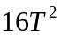 is acceleration due to gravity,
h(T) = 0 means height is zero ( melon is splatted on ground)
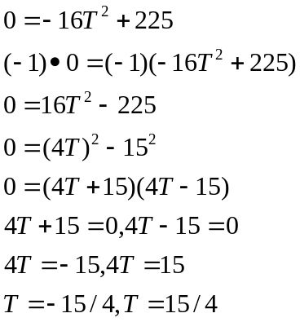
The water melon hits the ground in 3.75 secs (SPLATO)

Is, was or equals gives an equation..
Look for math words
Square means power of 2
Number means variable (or unknown)
Twice means 2 times

From or than switches order

Example
The square of a number minus twice the number the number is 63.

The number is going to be x therefore
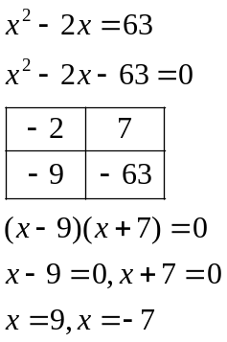

The number can be either 9 or -7

Example
The length of a rectangle is 5 feet more than the width, the area of the rectangle is 176 square feet
Find the dimensions of the rectangle.

Let the width of the rectangle be represented by w
The length of the rectangle is w +5
The area of a rectangle is length times width

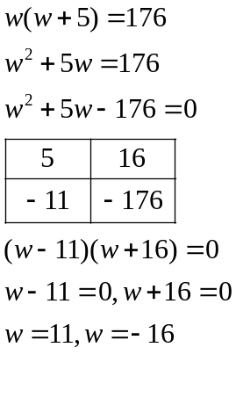
The width of the rectangle is 11 feet
The length of the rectangle is 11 feet plus 5feet give a total of 16 feet
The dimensions of the rectangle is 11 feet wide and 16 feet long.

Example
I need a sail for my racing boat,
Conditions:
- Triangular 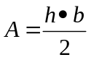
- Base must be 1 foot less than 3 times the height
- Area must be 210 square feet

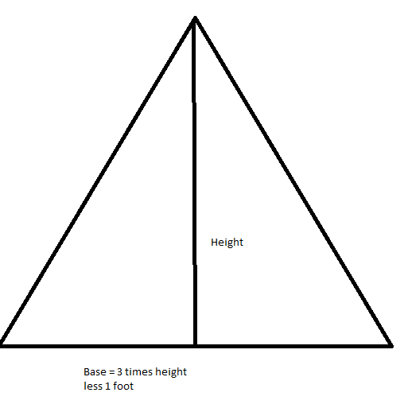

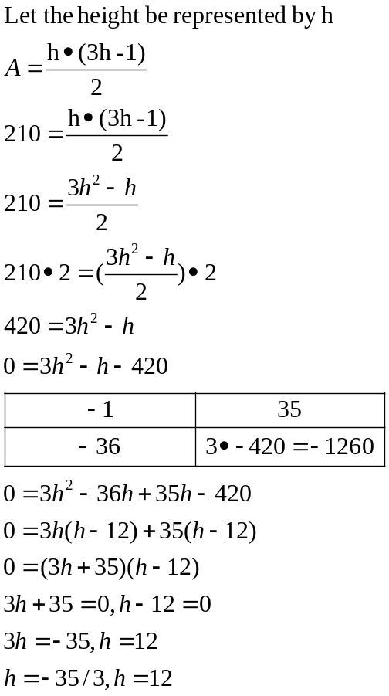

Height of the sail is 12 feet and the base of the sail is 3 times 12 less 1 foot gives the base of the sail at 35 feet

Pythagorean theorem

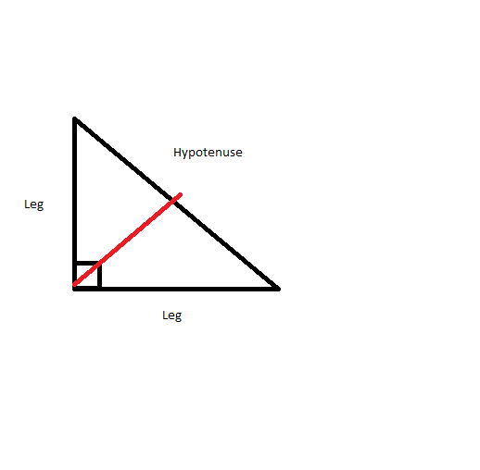

Leg length squared plus other leg length square equals the (length of the Hypotenuse squared)

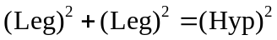

Consecutive

In order or back to back
When asked for something in an algebraic to be in consecutive order start with the variable x

When asked for the next consecutive number start with x then next number would be x+1, x+2, x+3

Consecutive Even/odd
x, x+2,,x+4

Example,
Find two consecutive odd integers whose product is 23 more than there sum

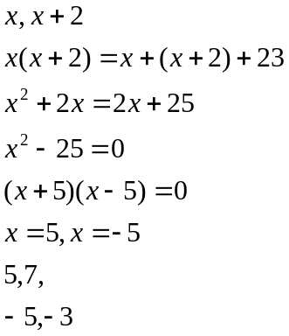

Example,
In a right triangle sides are consecutive even integers, find the lengths

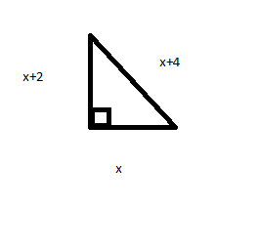
The lengths of the right triangle is x, x+2 and x+4
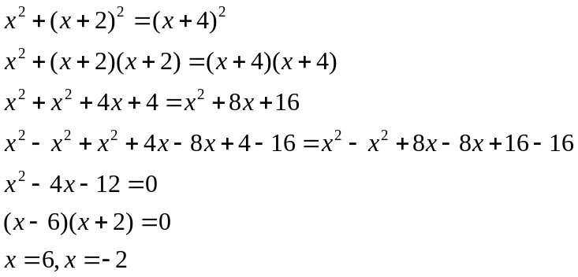

The length of the triangle is 6,8 with the length of the hypotenuse being 10
36+64=100

